Centre for International Relations

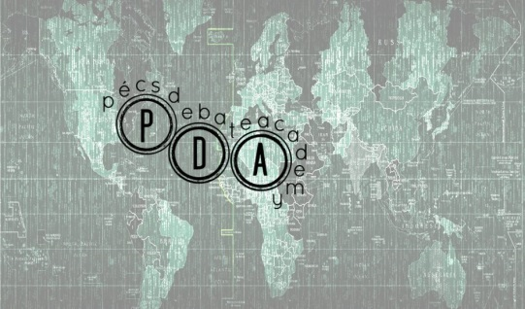

Pécs Debate Academy 2017 -
Summer School and Culture Week
'University Education and Student Life in the 21st Century'

Date
28 July, 2017 – 06 August, 2017

Call
Join our Pécs Debate Academy Summer School and receive up-to-date knowledge about the hot topics of today’s higher education!
Do you have an opinion and would like to speak up for yourself? If you feel inside the intention to express your thoughts, come and improve your debating skills with us learning to use the most effective content, style, speed, tone and volume!
Our unique Debate Academy Summer School will use a mixed methodology – you will learn about the interesting issues of higher education from experts of the field while you will also gain an opportunity to develop your speaking skills and learn to argue along the techniques of the British Parliamentary Debate style.
The Debate Academy Summer School will develop your critical thinking, your communication skills as well as your ability to analyze and understand the world around us. It will also give you the opportunity to make friends and have fun in a very welcoming international environment.
Program description

The special Pécs Debate Academy 2017 uses a mixed methodology. Students learn about the hot topics of higher education in 21st century from international and local experts while they also gain an opportunity to develop their speaking skills and learn to argue along the techniques of the British Parliamentary Debate style from highly qualified international debate trainers.
The Pecs Debate Academy is a debate training series that embeds a youth forum conference, which is supported by courses on introduction to debate systems, discussions, conference lectures, debate trainings, and a debate tournament.

The Pécs Debate Summer Academy gives an opportunity to young people from all over the world to meet each other and to discuss and debate over various questions and problems. Experienced debate trainers will lead the trainings and the discussions. The focus of the debates and presentations is on the higher education and student life of the 21st century. A Debate Tournament will close the training program with the Final Debate at the Court of Justice in Pécs. The subject will be discussed from different angles with the help of acclaimed debate trainers and invited guest lecturers/experts.
We are committed to emphasize non-frontal teaching: teambuilding activities and debate skills trainings, final debate tournament, on-topic and off-topic lectures, and also active off-programs. The participants can learn from each other and find common ground for common ways of thinking.
The Pecs Debate Academy will give participants to do more than just study. We pay special attention to providing the participants with a very enjoyable and unforgettable stay. Various intercultural programs will also be organized for the attendants at the different locations of the city of Pécs and of the University of Pécs that will celebrate the 650th anniversary of its foundation.

Social programs:
Cultural and interactive events such as concerts, country presentations, sports contests, social night, field trip, sightseeing

Who should apply: The program is open to undergraduate, graduate and PhD students

Earned credits: 6 ECTS credits

Language of instruction: English

Housing: Dormitory
Program fee: 0 EUR for Alps Adriatic Scholarship holders. The Alps Adriatic Scholarship covers the participation fee, 2 hot meals a day, accommodation plus the attendance on all the cultural programs. You only have to pay for your travel expenses.
Organizing unit: University of Pécs and SIEN Foundation

Application deadline for the Alps Adriatic Scholarship Scholarship: 5 May, 2017

Website:
www.pecsdebateacademy.hu
summerschool.pte.hu

Further information:
summerschoolpecs@pte.hu

